Grafted Stem Cells Display Vigorous Growth in Spinal Cord Injury Model

Newswise — NIBIB-funded researchers report in a recent study that they were able to use human stem cells to grow brand new nerves in a rat model of spinal cord injury. The neurons grew tens of thousands of axons that extended the entire length of the spinal cord, out from the area of injury. The procedure employs induced pluripotent stem cells or iPSCs, which are stem cells that can be driven to become a specific cell type -- in this case nerve cells-- to repair an experimentally damaged spinal cord. The iPSCs were made using the skin cells of an 86 year old male, demonstrating that even in an individual of advanced age, the ability of the cells to be turned into a different cell type (pluripotency) remained.
Lead author Paul Lu, Ph.D., and senior author Mark Tuszynski, MD, PhD, and their team at the University of California - San Diego Center for Neural Repair, performed the experiment building on earlier work using human embryonic stem cells in a similar rat spinal cord injury model.¹ The current work, described in the August 20 edition of Neuron, was performed to determine whether iPSCs could be used for spinal cord repair.²
The group is interested in using iPSCs to develop a potential repair for spinal cord injury (SCI) because with iPSCs, they can use cells taken from the person with the injury, rather than use donated cells such as human embryonic stem cells, which are foreign to the patient. This is an important advantage because it avoids any immune rejection that could occur with foreign repair cells.
In the current work, the iPSC-derived human neurons were embedded in a matrix that included a cocktail of growth factors, which was grafted onto the experimentally injured spinal cord in the rat model. After three months the researchers observed extensive axonal growth projecting from the grafted neurons, reaching long distances in both directions along the spinal cord, from the brain to the tail end of the spinal cord. The axons appeared to make connections with the existing rat neurons. Importantly, the axons extended out from the site of injury, an area with a complex combination of post-injury factors and processes going on, some of which are known to hinder neuronal growth and axon extension.
In the earlier study, Tuszynski and colleagues used human embryonic stem cells in a similar grafting experiment. In that study, axons grew out from the site of spinal cord injury and the treated animals had some restoration of ability to move affected limbs. The current study was undertaken to see if the same result could be achieved using the iPSC method to create the neurons used in the graft. While the use of iPSCs in the current study resulted in dramatic growth of the grafted neurons across the central nervous system of the rats, the treated animals did not show restoration of function in their forelimbs (hands). The researchers note that the human cells were still at a fairly early stage of development when function was tested, and that more time will likely be needed to be able to detect functional improvement.
Tuszynski went on to state, “There are several important considerations that future studies will address. These include whether the extensive number of human axons make correct or incorrect connections; whether the new connections contain the appropriate chemical neurotransmitters to form functional connections; whether connections, once formed, are permanent or transient; and exactly how long it takes human cells to become mature. These considerations will determine how viable a candidate these cells might be for use in humans.”
Lu, Tuszynski and their colleagues hope to identify the most promising neural stem cell type for repairing spinal cord injuries. Tuszynski emphasizes their commitment to a careful, methodical approach: “Ultimately, we can only translate our animal studies into reliable human treatments by testing different neural stem cell types, carefully analyzing the results, and improving the procedure. We are encouraged, but we continue to work hard to rationally to identify the optimal cell type and procedural methods that can be safely and effectively used for human clinical trials.”
1. Long-distance growth and connectivity of neural stem cells after severe spinal cord injury. Lu P, Wang Y, Graham L, McHale K, Gao M, Wu D, Brock J, Blesch A, Rosenzweig ES, Havton LA, Zheng B, Conner JM, Marsala M, Tuszynski MH. Cell. 2012 Sep 14;150(6):1264-73
2. Long-distance axonal growth from human induced pluripotent stem cells after spinal cord injury. Lu P, Woodruff G, Wang Y, Graham L, Hunt M, Wu D, Boehle E, Ahmad R, Poplawski G, Brock J, Goldstein LS, Tuszynski MH. Neuron. 2014 Aug 20;83(4):789-96

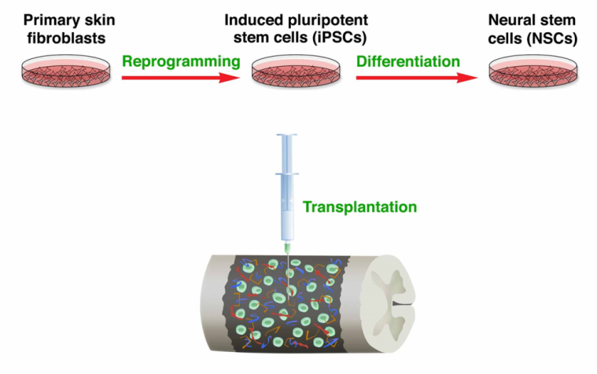
Outline of procedure using skin cells to create neural stem cells for injection into the site of spinal cord injury

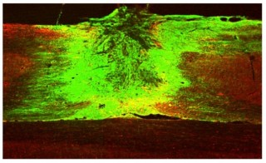

iPSC neural stem cells (labeled green) extend down spinal cord in both directions from the site of injury where the human neural stem cells were injected

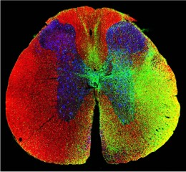

Cross section of treated spinal cord showing transplanted human neurons (green) extending into mouse white matter (red) and gray matter(blue)

